StrengthsQuest
a path to professional success and fulfillment

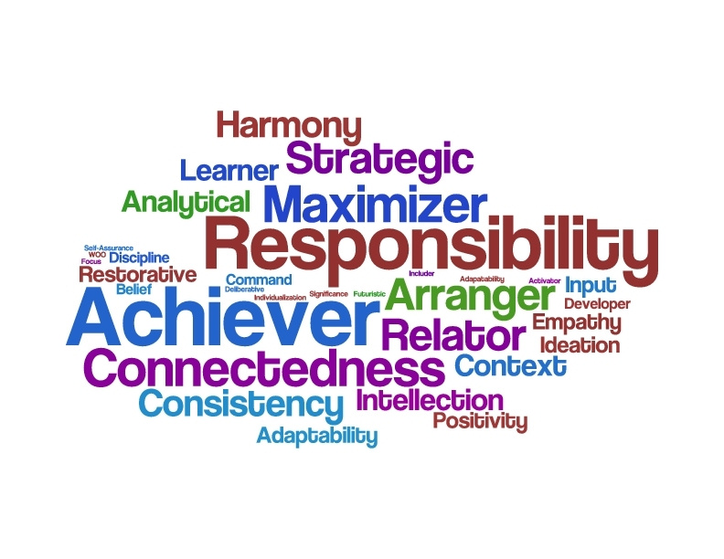

CEANY 2014 Conference

Presented by Christy Huynh
Associate Director, Career Services, SUNY Oswego
christy.huynh@oswego.edu

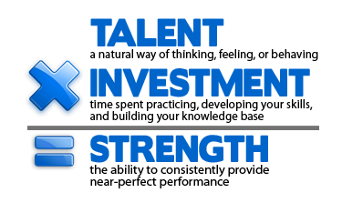
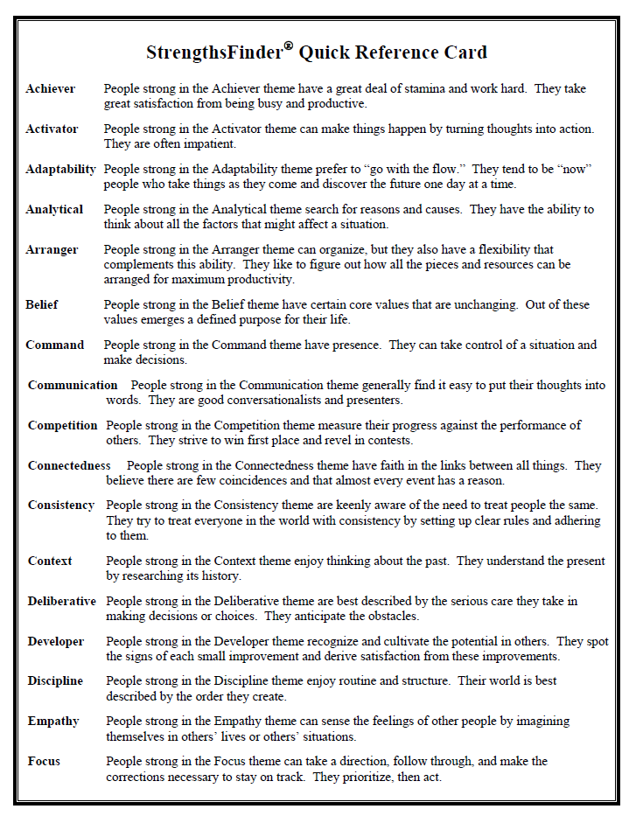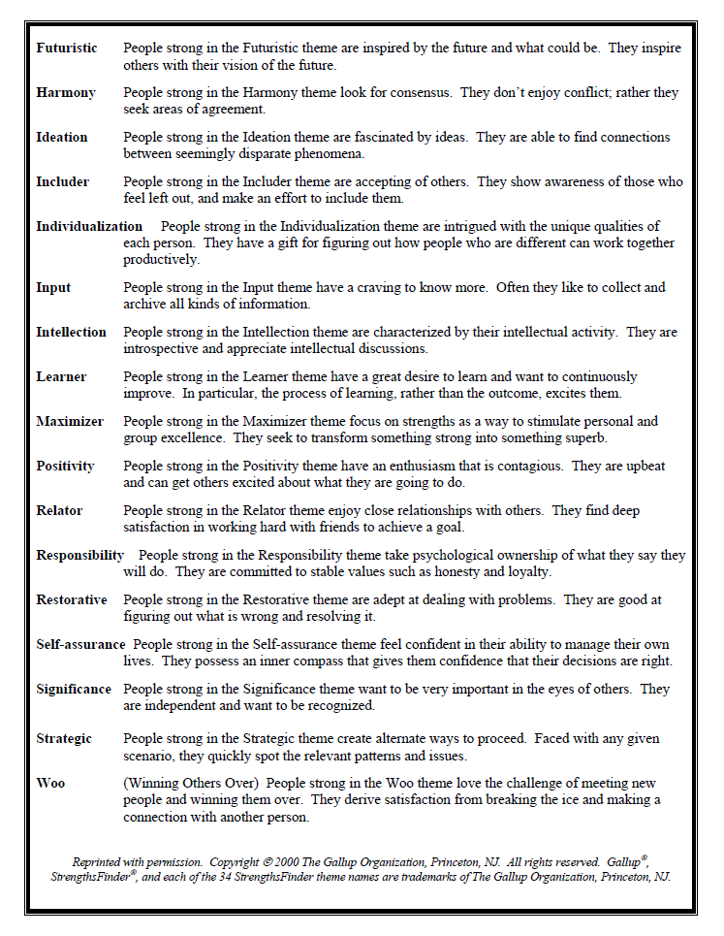

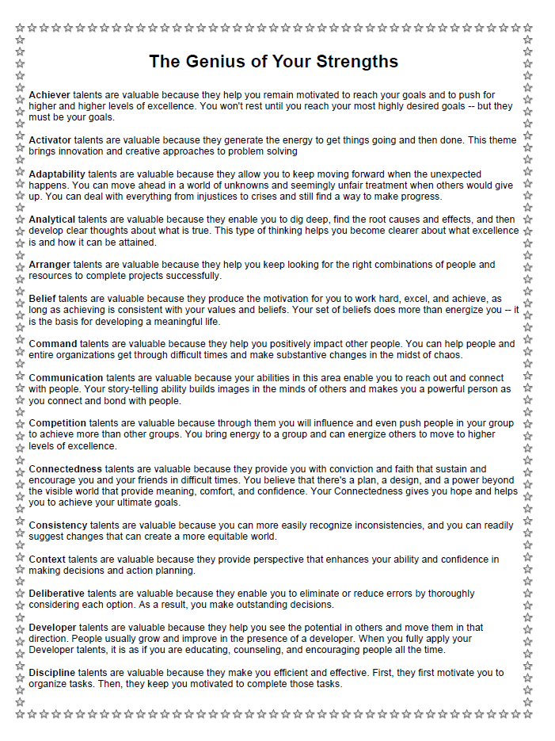
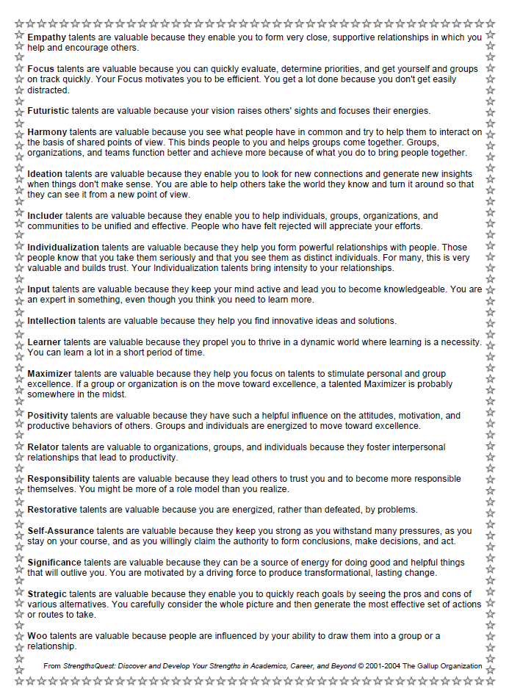

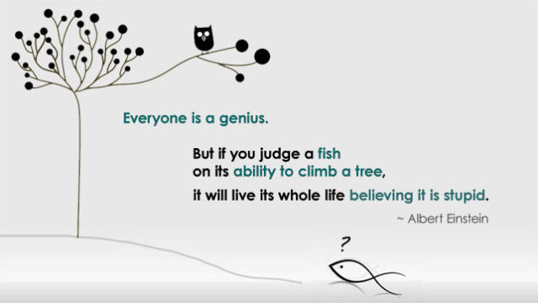

Scavenger Hunt
StrengthsQuest

Find 5 different people who have one Signature Theme that is NOT in your own top five.
Record each person’s name, theme name, and one benefit of that theme.

Name | Theme Name | One Benefit of the Theme

Find 5 different people who have one Signature Theme that is the SAME as one of yours.
Record each person’s name, theme name, and one benefit of that theme.

Name | Theme Name | One Benefit of the Theme

What Makes a Great Leadership Team?
Individuals don’t have to be well-rounded, but teams should be
by Tom Rath and Barry Conchie
Adapted from Strengths Based Leadership (Gallup Press, January 2009)
We found that it serves a team well to have a representation of strengths in each of these four domains. Instead of one dominant leader who tries to do everything or individuals who all have similar strengths, contributions from all four domains lead to a strong and cohesive team. Although individuals need not be well-rounded, teams should be.
This doesn't mean that each person on a team must have strengths exclusively in a single category. In most cases, each team member will possess some strength in multiple domains. A tool like Gallup's StrengthsFinder assessment can be useful in determining how all team members can maximize their contribution to the group's collective goals.
Executing | Influencing | Relationship Building | Strategic Thinking
Achiever  Arranger  Belief  Consistency  Deliberative  Discipline  Focus  Responsibility  Restorative | Activator  Command  Communication  Competition  Maximizer  Self-Assurance  Significance  Woo | Adaptability  Developer  Connectedness  Empathy  Harmony  Includer  Individualization  Positivity  Relator | Analytical  Context  Futuristic  Ideation  Input  Intellection  Learner  Strategic
Leaders with dominant strength in the Executing domain know how to make things happen. When you need someone to implement a solution, these are the people who will work tirelessly to get it done. Leaders with a strength to execute have the ability to "catch" an idea and make it a reality. For example, one leader may excel at establishing a quality process using themes such as Deliberative or Discipline, while the next leader will use her Achiever theme to work tirelessly toward a goal. Or a leader with strong Arranger may determine the optimal configuration of people needed to complete a task.
Those who lead by Influencing help their team reach a much broader audience. People with strength in this domain are always selling the team's ideas inside and outside the organization. When you need someone to take charge, speak up, and make sure your group is heard, look to someone with the strength to influence. For example, a leader with a lot of Command or Self-Assurance may use few words, but her confidence will continue to project authority and win followers. In contrast, a leader using Communication or Woo might get people involved by helping individuals feel comfortable and connected to the issue at hand.
Those who lead through Relationship Building are the essential glue that holds a team together. Without these strengths on a team, in many cases, the group is simply a composite of individuals. In contrast, leaders with exceptional Relationship Building strength have the unique ability to create groups and organizations that are much greater than the sum of their parts. Within this domain, a leader with Positivity and Harmony may work hard to minimize distractions and to keep the team's collective energy high. On the other hand, a leader with Individualization might use a more targeted approach to getting people involved. Or a leader with strong Relator or Developer may be a great mentor and guide as he pushes others toward bigger and better achievements.
Leaders with great Strategic Thinking strengths are the ones who keep us all focused on what could be. They are constantly absorbing and analyzing information and helping the team make better decisions. People with strength in this domain continually stretch our thinking for the future. Within this domain, a leader using Context or Strategic might explain how past events influenced present circumstances or navigate the best route for future possibilities. Someone with strong Ideation or Input may see countless opportunities for growth based on all of the information she reviews. Or a leader drawing from his Analytical theme might help the team drill into the details of cause and effect.

Applying My Signature Themes to My Career
StrengthsQuest

Professional responsibilities/
tasks that energized me My Signature Themes

______________________________ ______________________________

______________________________ ______________________________

______________________________ ______________________________

______________________________ ______________________________

______________________________ ______________________________

Professional tasks that
drain my energy Partners / Themes that can support me

______________________________ ______________________________

______________________________ ______________________________

